EXPERIMENT NO-10
AIM: Write a program in C to do disk scheduling – FCFS, SCAN, C-SCAN.
TOOLS/SOFTWARES REQUIRED: Dev C++
THEORY: The Banker's Algorithm is a resource allocation and deadlock avoidance strategy that tests safety by simulating the allocation of predetermined maximum possible amounts of all resources. It determines if a resource request can be granted safely without the system entering an "unsafe" state.
CODE (FCFS):
#include <stdio.h>
#include <stdlib.h>

int main() {
int n, i, head, totalSeek = 0;
printf("Enter number of requests: ");
scanf("%d", &n);
int req[n];
printf("Enter request sequence:\n");
for(i = 0; i < n; i++)
scanf("%d", &req[i]);
printf("Enter initial head position: ");
scanf("%d", &head);
for(i = 0; i < n; i++) {
totalSeek += abs(req[i] - head);
head = req[i];
}
printf("Total Seek Time = %d\n", totalSeek);
return 0;
}

OUTPUT:
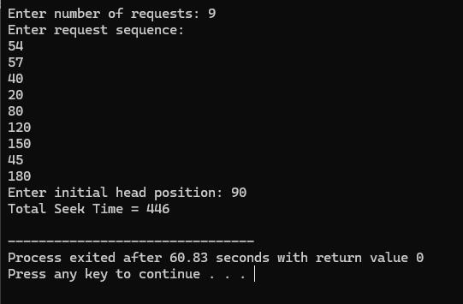

CODE (SCAN):
#include <stdio.h>
#include <stdlib.h>
int main() {
int n, head, size, i, j, totalSeek = 0, direction;
printf("Enter number of requests: ");
scanf("%d", &n);
int req[n];
printf("Enter request sequence:\n");
for(i = 0; i < n; i++)
scanf("%d", &req[i]);
printf("Enter initial head position: ");
scanf("%d", &head);
printf("Enter disk size: ");
scanf("%d", &size);
printf("Enter direction (0 for LEFT, 1 for RIGHT): ");
scanf("%d", &direction);
// Sort requests
for(i = 0; i < n; i++) {
for(j = i + 1; j < n; j++) {
if(req[i] > req[j]) {
int temp = req[i];
req[i] = req[j];
req[j] = temp;
}
}
}
int pos;
for(i = 0; i < n; i++) {
if(head < req[i]) {
pos = i;
break;
}
}
printf("\nSeek Sequence: %d", head);
// ?? If direction is RIGHT
if(direction == 1) {
// Move right
for(i = pos; i < n; i++) {
totalSeek += abs(req[i] - head);
head = req[i];
printf(" -> %d", head);
}
// Go to end
totalSeek += abs((size - 1) - head);
head = size - 1;
printf(" -> %d", head);
// Move left
for(i = pos - 1; i >= 0; i--) {
totalSeek += abs(req[i] - head);
head = req[i];
printf(" -> %d", head);
}
}
// ?? If direction is LEFT
else {
// Move left
for(i = pos - 1; i >= 0; i--) {
totalSeek += abs(req[i] - head);
head = req[i];
printf(" -> %d", head);
}
// Go to start
totalSeek += abs(head - 0);
head = 0;
printf(" -> %d", head);
// Move right
for(i = pos; i < n; i++) {
totalSeek += abs(req[i] - head);
head = req[i];
printf(" -> %d", head);
}
}
printf("\nTotal Seek Time = %d\n", totalSeek);
return 0;
}

OUTPUT:
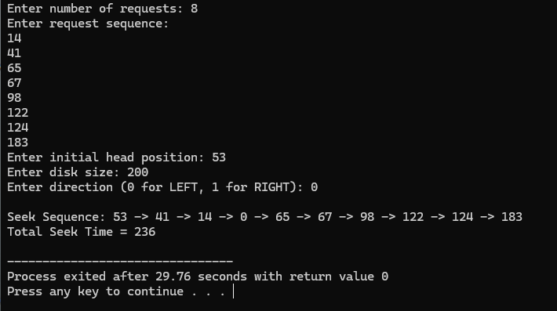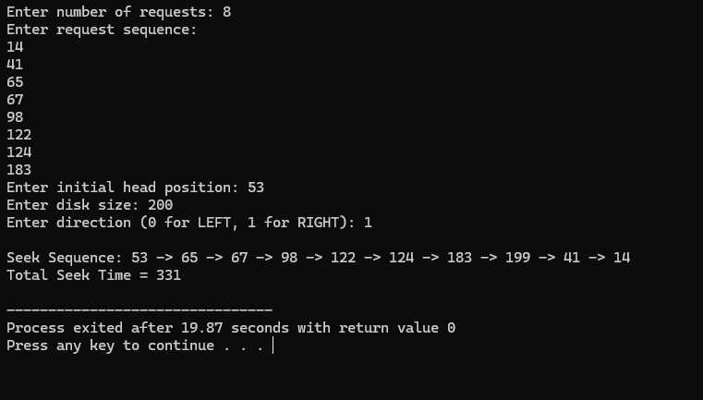
CODE (C-SCAN):
#include <stdio.h>
#include <stdlib.h>
int main() {
int n, head, size, i, j, totalSeek = 0, direction;
printf("Enter number of requests: ");
scanf("%d", &n);
int req[n];
printf("Enter request sequence:\n");
for(i = 0; i < n; i++)
scanf("%d", &req[i]);
printf("Enter initial head position: ");
scanf("%d", &head);
printf("Enter disk size: ");
scanf("%d", &size);
printf("Enter direction (0 for LEFT, 1 for RIGHT): ");
scanf("%d", &direction);
// Sort requests
for(i = 0; i < n; i++) {
for(j = i + 1; j < n; j++) {
if(req[i] > req[j]) {
int temp = req[i];
req[i] = req[j];
req[j] = temp;
}
}
}
int pos;
for(i = 0; i < n; i++) {
if(head < req[i]) {
pos = i;
break;
}
}
printf("\nSeek Sequence: %d", head);
// ?? If direction is RIGHT
if(direction == 1) {
// Move right
for(i = pos; i < n; i++) {
totalSeek += abs(req[i] - head);
head = req[i];
printf(" -> %d", head);
}
// Go to end
totalSeek += abs((size - 1) - head);
head = size - 1;
printf(" -> %d", head);
// Jump to start
totalSeek += (size - 1);
head = 0;
printf(" -> %d", head);
// Continue right
for(i = 0; i < pos; i++) {
totalSeek += abs(req[i] - head);
head = req[i];
printf(" -> %d", head);
}
}
// ?? If direction is LEFT
else {
// Move left
for(i = pos - 1; i >= 0; i--) {
totalSeek += abs(req[i] - head);
head = req[i];
printf(" -> %d", head);
}
// Go to start
totalSeek += abs(head - 0);
head = 0;
printf(" -> %d", head);
// Jump to end
totalSeek += (size - 1);
head = size - 1;
printf(" -> %d", head);
// Continue left
for(i = n - 1; i >= pos; i--) {
totalSeek += abs(req[i] - head);
head = req[i];
printf(" -> %d", head);
}
}
printf("\nTotal Seek Time = %d\n", totalSeek);
return 0;
}

OUTPUT:
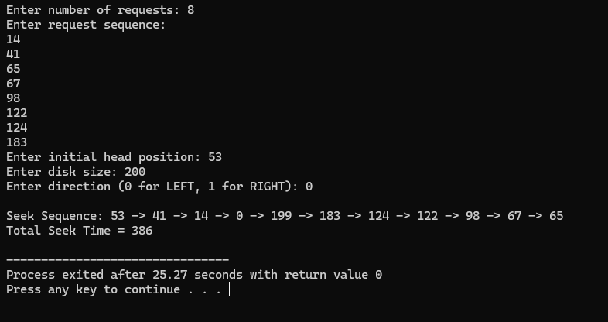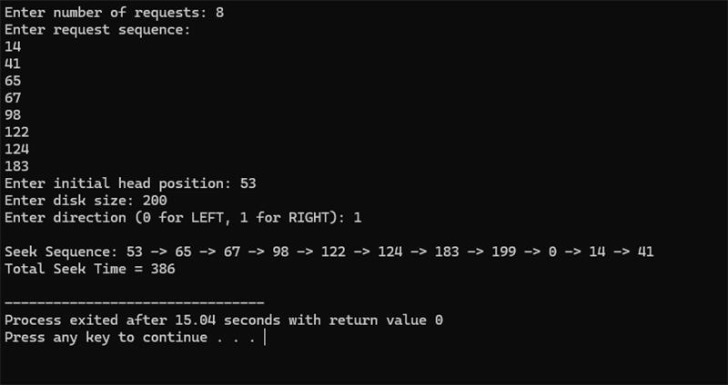
CONCLUSION:
Hence, we have written a program in C language to learn about and implement disk scheduling using three algorithms: FCFS, SCAN, C-SCAN.

